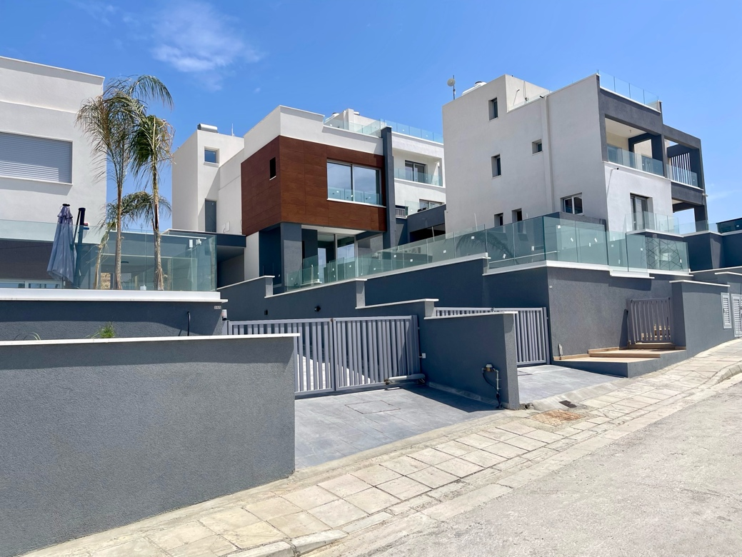 | HOUSE 3B  COMPLETED CONSTRUCTION  PRICE  € 736.000 + VAT  184 sq.m x € 4.000

CONSTRUCTION YEAR: 2025
VIEW: Mediterranean Sea and Troodos Mountains
ENERGY EFFICIENCY: Class A, received Energy Performance Certificate (EPC)
RESIDENTIAL COMPLEX IMPROVEMENT: the road and sidewalks were built, street lighting was connected

PLOT AREA: 416.5 sq.m

BOUNDARY WALLS: the plot is fenced along the entire perimeter
INTERNAL FENCE IN THE YARD: glass and marble
YARD COVERING: tiles
GREEN AREAS: included in the plot plan
POOL: yes
COVERED PARKING: yes

COVERED AREA: 184 sq.m

BEDROOMS: 3
BATHROOMS: 3

GROUND FLOOR: 97 sq.m includes kitchen, dining area, living room, bathroom, covered veranda, covered parking.
FIRST FLOOR: 75 sq.m includes master bedroom, 2 bedrooms, 2 bathrooms.
ROOF GARDEN: 75 sq.m includes 12 sq.m of covered area; glass and marble fencing.

A fully completed villa (house 3B) in the residential complex Chrysos Hills, which will consist of 17 villas and is located at Palerou 16, Parekklisia, 4520, Limassol. This is a rapidly developing area with a constantly growing demand for real estate, guaranteeing the preservation and growth of your capital.
Villa price € 736.000 + VAT.
The location of the complex combines the seclusion of a natural environment with proximity to the city – Limassol is just a few minutes' drive away. Shops, cafes, sports and medical facilities, as well as local authorities, are within walking distance. Nearby there are beaches that meet the ecological and sanitary certification of the Blue Flag: Parekklisia beach, St. Raphael beach.
The complex is situated on the top of a hill, one of the highest points in the area. From each villa, there is a panoramic view of the Mediterranean Sea and the mountains, with streams of fresh air flowing toward the sea.
Due to its geographical location, the complex is naturally secluded from other plots. The architecture of the complex is designed in a unified style, while each villa has its own individual design and functional features, and comes with a plot of land with a well-thought-out spatial layout.
The infrastructure of the residential complex is well-equipped: necessary underground utilities for 17 villas have been laid, roads and sidewalks have been constructed, stormwater drainage is in place, and street lighting has been installed, along with three fire hydrants. The internal roads of the complex are cul-de-sacs and are used only by the residents, ensuring privacy and safety for children and pets.
The villa is located inside the complex, making it cozy and private at the same time. Officially connected to utilities.
The plot includes green zones of various types, so you can create a garden according to your taste, as well as a swimming pool with a spacious terrace for relaxation.
The Ground Floor features a kitchen, dining area and living room, all with access to a covered veranda and a zone that you can use, for example, as a BBQ area. Pay attention to our photos of the covered veranda and the surrounding area: it is enclosed with glass and has green zones nearby, meaning you can create the perfect space for relaxation, work, and meetings at your home. Also on this level, there is a covered parking area with a separate entrance to the house.
The First Floor includes a master bedroom with a beautiful panoramic view, 2 spacious bedrooms, 2 bathrooms.
An additional advantage of the villa is the spacious Roof Garden, from which you can fully enjoy the nature of Cyprus, its sunrises and sunsets.
The project was developed based on recommendations and calculations obtained from geological, seismic and other necessary studies. The construction uses tunnel formwork, where vertical reinforced concrete columns and horizontal slabs create a strong monolithic structure with high seismic resistance. The exterior and interior walls of the house are made of brick. To increase the stability of the building, the boundary walls and pool are strengthened using the injection grouting method, which involves creating strong concrete columns underground to reinforce the soil beneath the foundation.
The villa is certified with the highest energy efficiency Class A. The building is optimally oriented to the cardinal directions, designed with an energy-efficient shape and glazing area, and equipped with modern materials and heat-insulation technologies.

